Directions:
1. Mark your confusion.
2. Show evidence of a close reading. Mark up the text with questions and/or comments.
3. Write a one-page reflection on your own sheet of paper.

Careless Social Media Use May Raise Risk of Identity Fraud
Ann Carrins, New York Times - February 29, 2012
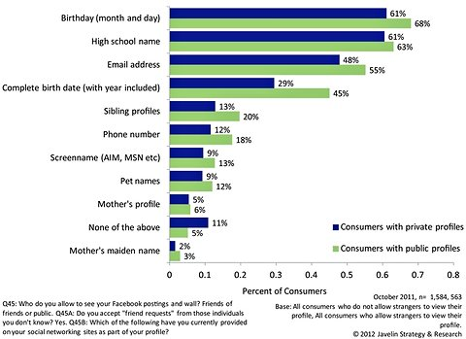

Users of social media who don't restrict the information they share online have a higher risk of identity fraud, a new report from Javelin Strategy & Research finds.
The incidence of identity fraud in 2011 rose to about 5 percent of the adult United States population, up from roughly 4 percent the year before, the report found. But among Facebook users with public profiles, the rate was 7.5 percent, while users who accept "friend" requests from strangers had an even higher rate, of nearly 9 percent.
The study defined a "public" profile as one that allows strangers to see personal information, including profiles open to "friends of friends." Roughly a quarter of Facebook users have public profiles, the study found.
Fred Wolens, a spokesman for Facebook, dismissed the survey's findings, saying it doesn't reveal any higher risk of fraud among Facebook users because the percentages reported were within the survey's stated margin of error. "This survey doesn't prove anything," he said.
He added that it is "common sense" that if you post about your dog using its name on Facebook, you probably shouldn't be using your dog's name as any sort of password.
While there's no direct "causation" between using social media and identity fraud, the report found, the behavior of those participating is probably a factor. Information revealed in public profiles, including your full date of birth or your mother's maiden name or the name of your pet, is valuable to thieves because companies often use such information to verify your identity online. Nearly half of those with public Facebook profiles revealed their full birth date, including the year, compared with about a third of those with private profiles, the report found.
"The proper use of privacy settings on social network profiles is essential to reconcile the connectivity of social media with the protection of personal information," the report said.
A probable factor in the rise in identity theft in 2011, the report found, was an increase in reported data breaches, like those at Sony PlayStation and Epsilon. Fifteen percent of Americans were notified that their information was lost in a data breach in 2011, and those notified of a data breach are almost 10 times more likely to be an identity fraud victim than someone who wasn't notified, Javelin found. But, the report found, the dollar amount of the typical fraud incident is declining. "Although fraud is more pervasive," the report said, "it is less severe."
Smartphone users, too, face a higher risk, the report found, with nearly 7 percent of users experiencing fraud in 2011. Smartphone users' generally higher incomes may contribute to their higher risk, but behavioral factors may also play a role, the report found. For instance, a third of smartphone users store personal information on their phones, but only 16 percent have installed software that allows them to remotely wipe the device if it is lost or stolen.
The report is based on survey conducted in October of 5,022 adults recruited by the survey firm Knowledge Networks, which uses address-based online sampling. The margin of sampling error is plus or minus 2 percentage points. (For a subset of questions asked of fraud victims, the margin of sampling error is 3 percent.)
Reflection Prompt:
The Duke and King were able to easily convince most of the townspeople that they were the true Wilks brothers. Unfortunately, identity fraud still exists today. Do you think that leaving social media sites open to the public increases your chances of experiencing identity fraud? What steps should people take to guard their privacy when using social media?

