Is Roxane a Good Match for Cyrano?
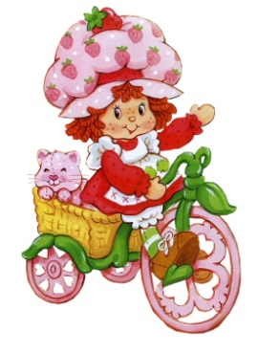
Here's Strawberry Shortcake. She's not really supposed to be Roxane in this picture, but she could be. For example, it could be a picture of Roxane (played by Strawberry Shortcake) bringing supplies to Cyrano and his men in a scene from later in the play, if there were a version called "Cyrano and Roxane on Bikes."
But there isn't.
The question remains, though: Is Strawberry Shortcake a prescieuse like Roxane?
What is a precieuse?
from the American Shakespeare Company:
The Precieuses (prey-see-oo z-iz)
• Precieuses were bourgeois (or conventional middle class), witty, well-educated women who gathered together in salon settings to discuss poetry, love, and, most importantly, the French language.
• Precieuses analyzed the French language in terms of vocabulary, denotations, connotations, metaphors, and periphrasis (long and flowery speech). The precieuses’ goal was to bring eloquence and flair to the historically dry use of French language.
• In Cyrano de Bergerac, Roxane is a precieuse, which affects her behavior in the play in both subtle and obvious ways. Roxane’s lines about getting milk when she wants cream are indicative of her being a precieuse—instead of wanting something common, she wants something rich.
• Roxane’s love for the language of Cyrano’s letters is also attributable to her being a precieuse. Cyrano’s elegant, flowery, embroidered language of love is precisely what the precieuses spent all their time talking about.
Question
Roxane is attracted to Cyrano’s language and by the definition of a true precieuse, she should be able to match him in wit and intelligence. Cite examples proving that Roxane is a language-match for Cyrano, or cite examples demonstrating that she is not.
Are there other things, besides language, that Cyrano and Roxane might find attractive about each other?

